CHAPTER 1

INTRODUCTION
  - BACKGROUND
Driving under the influence of alcohol continues to be one of the nation’s most
serious problem faced by the general public. It is a known fact that under the
influence of alcohol the driving skills is impaired and the risk of involvement in
accidents increases exponentially.
One study estimates that eliminating alcohol would reduce traffic fatalities by 47 percent (± 4%), equivalent to a reduction of between 20,000 and 24,000 fatalities
annually. There is no doubt that a reduction in alcohol-impaired driving would result in a substantial savings of human lives and resources, worldwide.
India had earned the questionable qualification of having a greater number of
fatalities because of street mishaps on the society. Street wellbeing is rising as a
noteworthy social worry far and wide, particularly in India. Drinking and driving is as of now a genuine general medical issue, which is probably going to rise as a standout amongst the most critical issues sooner rather than later. The primary reason behind this task is "Drunk driving detection". Since numerous mishaps are increasing due to the liquor utilization of the driver or the individual who is driving the vehicle.
Subsequently Drunk driving is a noteworthy reason of mischances in all nations everywhere throughout the world. Thus, the framework diminishes the quantum of street mischances and fatalities because of drunk driving in future.
Drunk driving is the purpose for the vast majority of the deaths, Since the Drunk
Driving Detection and Car Ignition Locking Using Arduino intends to change that with mechanized, straightforward, noninvasive liquor wellbeing check in vehicles. Alcohol sensor is implanted on the steering of the car, to such an extent that when the level of liquor crosses an admissible breaking point, where the start of vehicle will stopignition and the motor will stop. The Arduino processor always uses the liquor.

1.2 OBJECTIVE
The target of this projectis to give an ideaand inventive method for avoiding drunken
driving of a Motorcar by locking the car. Likewise, to permita man who is not alcoholic to drive a same Motorcar. To broaden this thought with more innovative headways and make it accessible in a financially effective way. We need to plan a sort of framework which can recognize the alcohol content in the cars to prevent the conduct of alcoholic driving.
The sensor will be fixed close to the driver's seat. The driver should breath to the
system before the individual begins the car. On the off chance that the alcohol level
identified is underneath the permissible standard, the car can be started regularly. In the event that the alcohol level is over the suitable standard, the framework will send caution to the driver through LCD display. The framework ought to be protected, delicate, exact, advantageous and cheap. This sort of framework can be fixed on each
car to guarantee the driver's driving security.

CHAPTER 2

THEORETICAL CONCEPTS

INTRODUCTION

We hear lot of accidents due to drunk driving and it will not be in stable condition. So it rash driving is the in convenience for other road death for the drunk driver and not for others.
In this system uses a compact arduino uno board. Programs are developed in embedded C.The main purpose for this project is “Automatic Engine Locking System Through Alcohol Detection using Arduino”. Most of these days many accidents are happening became of the alcohol detection of the driver or the person who is in the vehicle. Almost all the countries in the world are facing major accidents because of Drunk & Drive. In this project is designed for safety of the people seating the vehicle.
Alcohol Detector in Car is intended for the safety of the general population seating inside the car. This project ought to be fitted/introduced inside the vehicle.Alcohol sensor will be appended with Arduino. While liquor is noticed by the sensor, sensor sends the input voltage to Arduino. On the off chance that there are any hints of Alcohol over as far as possible, at that point the framework will lock the Engine in the meantime will automatically give a buzzer, we can reduce the accidents by checking the driving individuals on the roads. Drunk driving is one of the intense national and worldwide street security issue.

CHAPTER 3

COMPONENTS

The following components are used for indoor air quality monitoring system
- MQ-3 sensor
- Arduino Uno 3)16x2 LCD
- Breadboard
- 10K potentiometer 6)Buzzer
7)Relay module
8)Jumper wires
9)LED
10)DC Motor
11)9V Battery

COMPONENTS AND DEFINITIONS

    - ARDUINO UNO

The ATmega328P-based Arduino Uno is a microcontroller board.

It has 14 digital I/O pins, 6 analogue I/O pins, a 16 MHz quartz crystal, a USB connection, a power jack, an ICSP header, and a reset button.

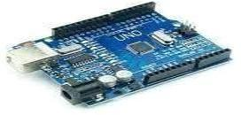

Fig 3.1: ARDUINO UNO

3.1.2 MQ 3 SENSOR

his module is made using Alcohol Gas Sensor MQ3. It is a low cost semiconductor sensor which can detect the presence of alcohol gases at concentrations from 0.05 mg/L to 10 mg/L. The sensitive material used for this sensor is SnO2, whose conductivity is lower in clean air.

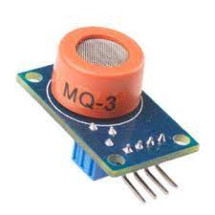

Fig 3.2: MQ 135 SENSOR
3.1.3 RELAY MODULE
The relay module is an electrically operated switch that can be turned on or off deciding to let current flow through or not. They are designed to be controlled with low voltages like 3.3V like the ESP32, ESP8266, etc, or 5V like your Arduino

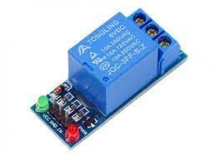

Fig 3.3 Relay Module

3.1.4 9V BATTERY

The most common type of nine-volt battery is often called a 9-volt, although there are less common nine-volt batteries of different sizes. Codes for the usual size include PP3 (for size and voltage, any technology),
6LR61 (IEC code for alkaline batteries), and in Japan 006P.

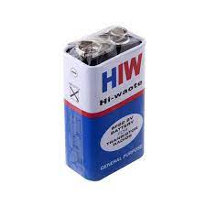

Fig 9V Battery

3.1.5 DC MOTOR

A direct current (DC) motor is a type of electric machine that converts electrical energy into mechanical energy. DC motors take electrical power through direct current, and convert this energy into mechanical rotation.

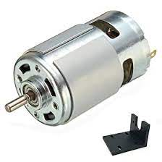

Fig DC MOTOR

3.1.4 BUZZER

A buzzer, also known as a beeper, is an audio signalling device. When the level of air pollution exceeds a certain threshold, the Buzzer begins to beep, signalling danger.

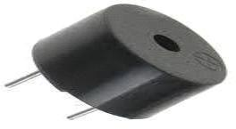

Fig 3.4 : Buzzer

3.1.5 LIGHT EMITTING DIODE(LED)

A light-emitting diode (LED) is a semiconductor light source that emits light when current flows through it.In this project led blinks if the air quality is poor.
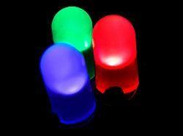
Fig 3.6:LIGHT EMITTING DIODE

3.1.7 POTENTIOMETER

A potentiometer is a three-terminal resistor with a sliding or rotating contact that forms an adjustable voltage divider.

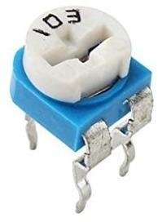
Fig 3.7:POTENTIOMETER

3.1.5 LIQUID CRYSTAL DISPLAY (LCD)

This is a straightforward (16x2) 16 character by 2 line display.The text is black on a green background.
It is used to show the relative humidity and air pressure in PPM.

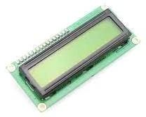

Fig 3.5:LIQUID CRYSTAL DISPLAY

JUMPER WIRES
Jump wire (also known as jumper, jumper wire, jumper cable, DuPont wire or cable) is an electrical wire, or group of them in a cable, with a connector or pin at each end, which is normally used to interconnect the components of a breadboard or other prototype or test circuit, internally or with other equipment or components, without soldering.
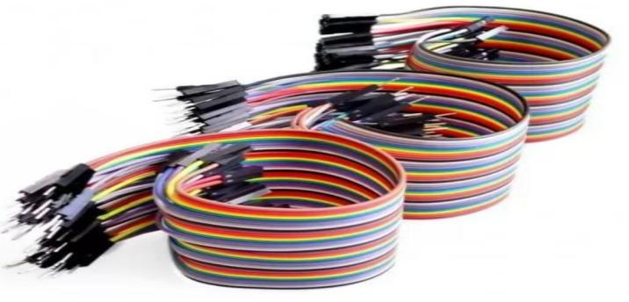

Fig 3.9:JUMPER WIRES]

BREAD BOARD

A breadboard is a construction base for prototyping of electronics. A breadboard is used to build and test circuits quickly before finalizing any circuitdesign. The breadboard has many holes into which circuit components like ICs and

resistors can be inserted .
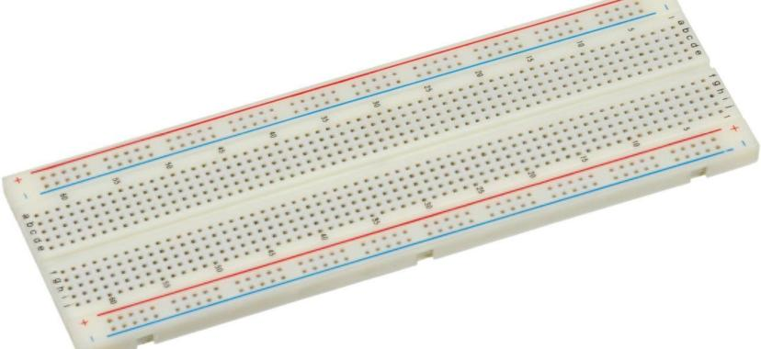
Fig 3.8:BREAD BOARD

CHAPTER 4

SYSTEM MODELLING TO SIMULATION

CIRCUIT DIAGRAM

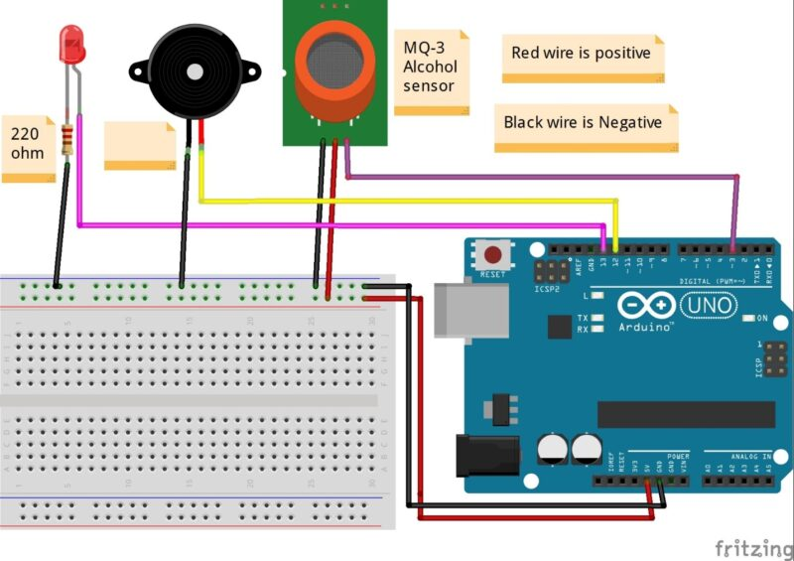

Fig 4.1: CIRCUIT DIAGRAM FOR PROJECT

CIRCUIT OPERATION

The Alcohol Detection with Engine Locking system helps to reduceaccidents which are occurring due to drunk driving. ... The sensor provides output on the basis of the concentration of the alcohol, if the alcohol concentration is higher the conductivity of MQ-3 sensor increases which in turn gives the reading to ARDUINO.

BLOCK DIAGRAM
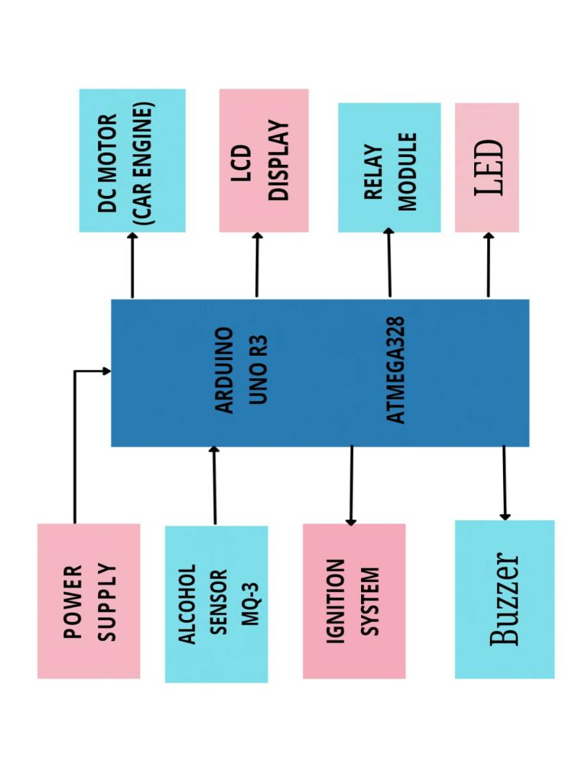

Fig 4.3:BLOCK DIAGRAM

4.4 ALGORITHM

STEP 1: Connect the circuit as per the circuit diagram.

STEP 2: Power on the system

STEP 3: checks for alcohol level concentration

STEP 4: if alcohol level is detected beyond the threshold value

STEP 5: turn off car engine

STEP 5: Else

STEP 6: Car engine running

STEP 8: Go to step 1for to check again and again

STEP 9: otherwise stop

4.5 ADVANTAGES

1.The road accidents will be reduced.
2.Non drunken person also escaped from risk.
3.There is no damage to the life of person and his vehicle

CHAPTER 5

RESULTS AND CONCLUSIONS

5.1 TEST AND RESULTS

The MQ3 Alcohol Sensor and the 16x2 LCD Display is interfaced with ARM-7
(LPC2148) Microcontroller.
b) MQ3 Sensor senses alcohol and indication of high Alcohol content is through the
external LED Light present on the sensor board.
c) The LCD display is used to display the results given by the MQ3 Sensor.
d) The Switch is used to ensure the driver does not tamper with the system

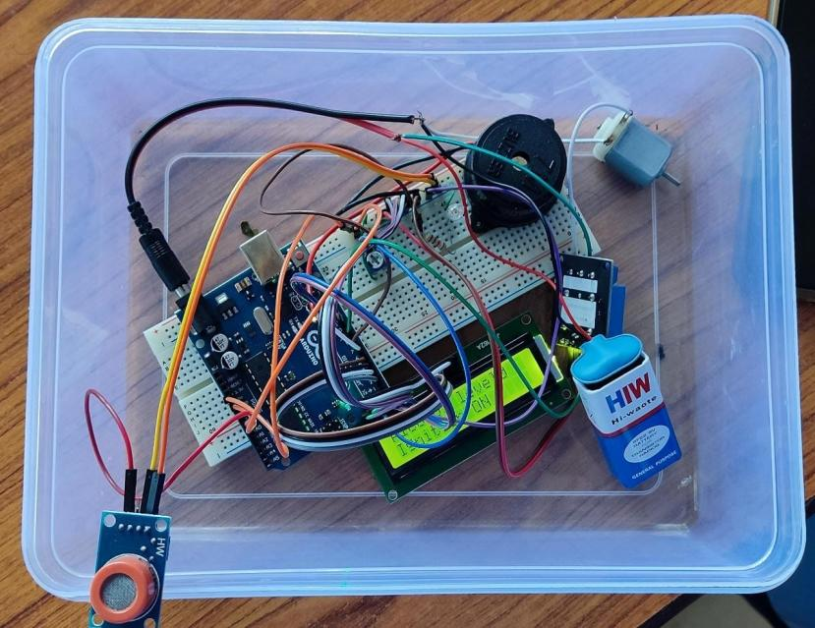

Fig 5.1 OUTPUT IMAGE

CONCLUSION

This project we have built up areal time model that can automatically lock themotor engine when In a drunken driver tries to drive a car. These days, car collisions are mostly observed. By fitting this alcohol sensor into the car, we can save the life of the driver and furthermore the rest of the travelers. The life time of the task is high. It has low or zero support cost and obviously low power utilization. This is a developed system to check drunken driving. By executing this outline a safe car ravel is possible decreasing the mishap rate because of drinking. By executing this outline, drunken drivers can be controlled so are the mishaps because of drunken driving

REFERENCE

Referred by the paper published by International Journal of Engineering Research & technology (IJERT) http://www.ijert.org

APPENDIX

PROJECT CODE

[14:43, 04/02/2022] 87: #include <LiquidCrystal.h>
const int rs = 12, en = 11, d4 = 5, d5 = 4, d6 = 3, d7 = 2;
LiquidCrystal lcd(rs, en, d4, d5, d6, d7);
int val;
int alcohol = A0;
int redled = 7;
int buzzer = 6;
int motor1 = 8;
int sensorval = 400;

void setup() {
lcd.begin(16, 2);
Serial.begin(9600);
pinMode(redled, OUTPUT);
pinMode(buzzer, OUTPUT);
pinMode(motor1, OUTPUT);

}

void loop() {
val = analogRead(alcohol);
delay(300);

if(val > sensorval)
{
Serial.print("Alcohol level = ");
Serial.println(val);
lcd.clear();
delay(100);
lcd.setCursor(0, 0);
lcd.print("Alcohol level");
lcd.print(val);
lcd.setCursor(0,1);
lcd.print("Alcohol Detect");
digitalWrite(buzzer, HIGH);
digitalWrite(redled, HIGH);
digitalWrite(motor1, LOW);
delay(500);
lcd.clear();

}
else{
Serial.print("Alcohol level = ");

